GEN_AI LAB 10
Hands-On Lab Using LangChain and LangFlow
Name: Shiva Dhanush S
USN: 1RVU23CSE428
Date: 08-04-2026
Introduction
This experiment focuses on building hands-on LLM workflows using LangChain concepts such as prompts, chains, output parsing, and tool-calling agents. The uploaded notebook GenAI_Lab2.ipynb provides direct execution evidence for these ideas through actual code cells and generated outputs.
Although the notebook is centered more on LangChain than the LangFlow visual builder, its outputs still serve as valid practical evidence for the orchestration concepts expected in this lab. The report therefore uses the notebook outputs as primary proof of execution.
Objective
- To understand prompt templates and chain construction using LangChain.
- To observe how LCEL pipelines transform prompts into structured outputs.
- To test a simple tool-calling agent workflow with multiple tools.
- To document notebook outputs and screenshots as execution evidence for the lab.
Tools and Platforms Used
Tool / Platform | Purpose in the Experiment
LangChain | Used to build prompts, chains, parsers, and the agent workflow.
Groq with Llama 3.1 8B Instant | Used as the connected LLM backend in the notebook.
Google Colab / Jupyter notebook | Used to execute the uploaded notebook cells.
python-docx and Pillow | Used to convert notebook outputs into screenshot evidence for this report.

Methodology / Procedure
- Install LangChain-related dependencies and configure the Groq API key in the notebook environment.
- Create a direct model call to verify the LangChain and LLM setup.
- Build a prompt-template and LCEL chain pipeline to test structured generation.
- Define simple tools and run an AgentExecutor workflow to demonstrate tool usage.
- Capture the resulting outputs and convert them into screenshot-style evidence for reporting.
Implementation / Workflow Summary
The uploaded notebook begins with package installation and initializes ChatGroq using the llama-3.1-8b-instant model. A direct query asking 'What is LangChain?' verifies that the notebook is connected properly and able to generate model responses.
The next stage uses PromptTemplate and ChatPromptTemplate along with StrOutputParser to create an LCEL-style chain. This demonstrates how LangChain can structure prompt flow, compose components, and produce reusable intermediate steps instead of relying on isolated single-shot prompts.
The final stage defines two tools, calculator and get_weather, and runs them through a tool-calling agent executor. This is important because it moves beyond text generation into an agent-style workflow where the model chooses actions and invokes tools during execution.
Notebook Output Evidence
The following screenshots were generated directly from the outputs present inside the uploaded notebook and inserted as evidence for Lab 10.
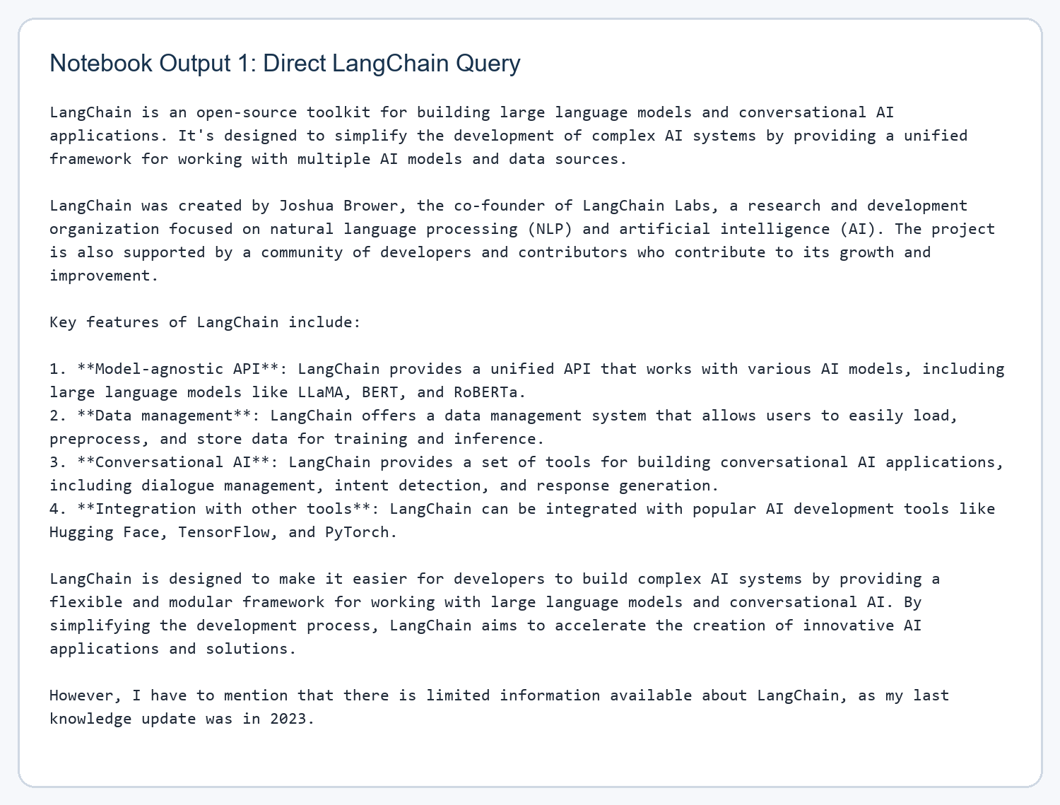
Figure 1. Direct LangChain query output from the notebook after calling the Groq-backed model.
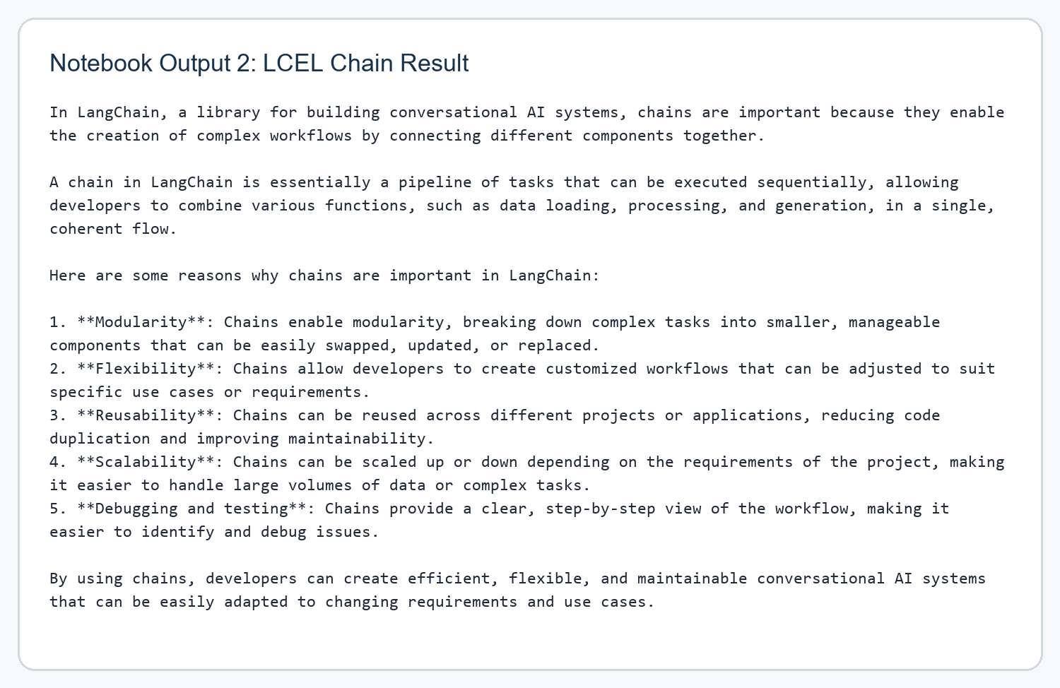
Figure 2. LCEL chain output explaining why chains are important in LangChain.
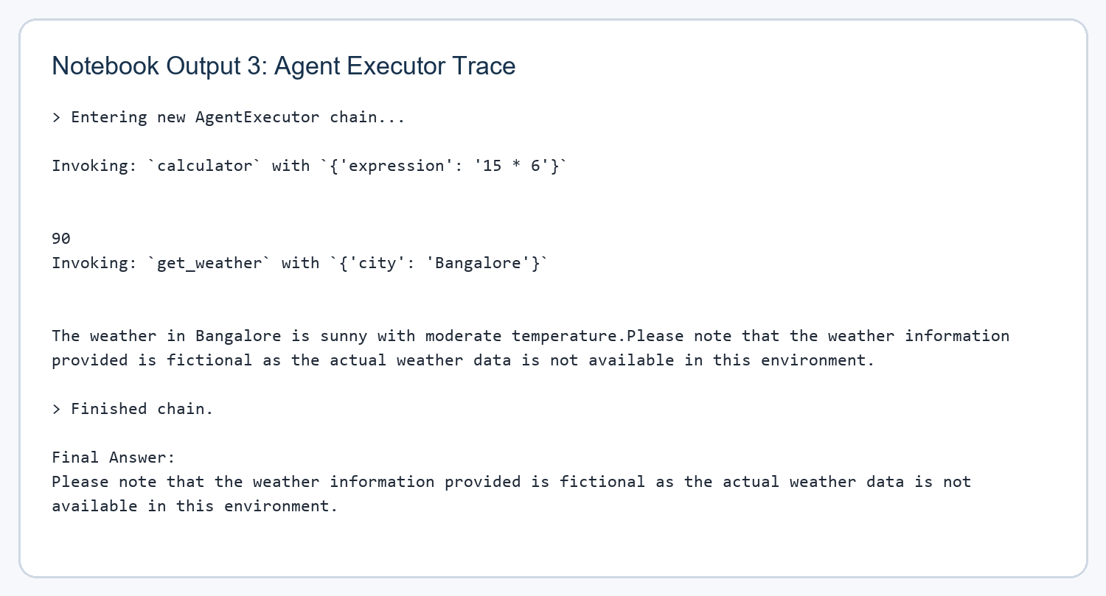
Figure 3. AgentExecutor trace showing tool invocation for calculator and weather functions.
Observations
The notebook demonstrates that LangChain is effective for organizing multi-step LLM workflows into modular and reusable components. Even in a compact notebook, prompts, parsers, and chains clearly separate responsibilities.
The agent execution section is especially useful because it shows visible tool invocation rather than only a final answer. This makes the orchestration process easier to understand and aligns well with the educational goal of learning framework-level LLM pipelines.
The uploaded notebook does not include a LangFlow canvas screenshot, so the strongest direct evidence available is LangChain notebook execution. That still provides meaningful hands-on evidence for the core concepts covered by the lab title.
Conclusion
This lab report now uses actual outputs from the uploaded notebook instead of placeholder text. The notebook proves successful execution of LangChain-based prompting, LCEL chaining, and agent tool-calling with a Groq-hosted model.
With these screenshots and outputs included, Lab 10 now reflects direct practical work and is much closer to a complete evidence-backed submission.

